**EXP NO: 16 DATE:15-03-24**

**Aim:** To Change Hardware compatibility of a VM (Either by clone/create new one) which is already created and configured.

**Implementation:**

1.select typical and create a new virtual machine

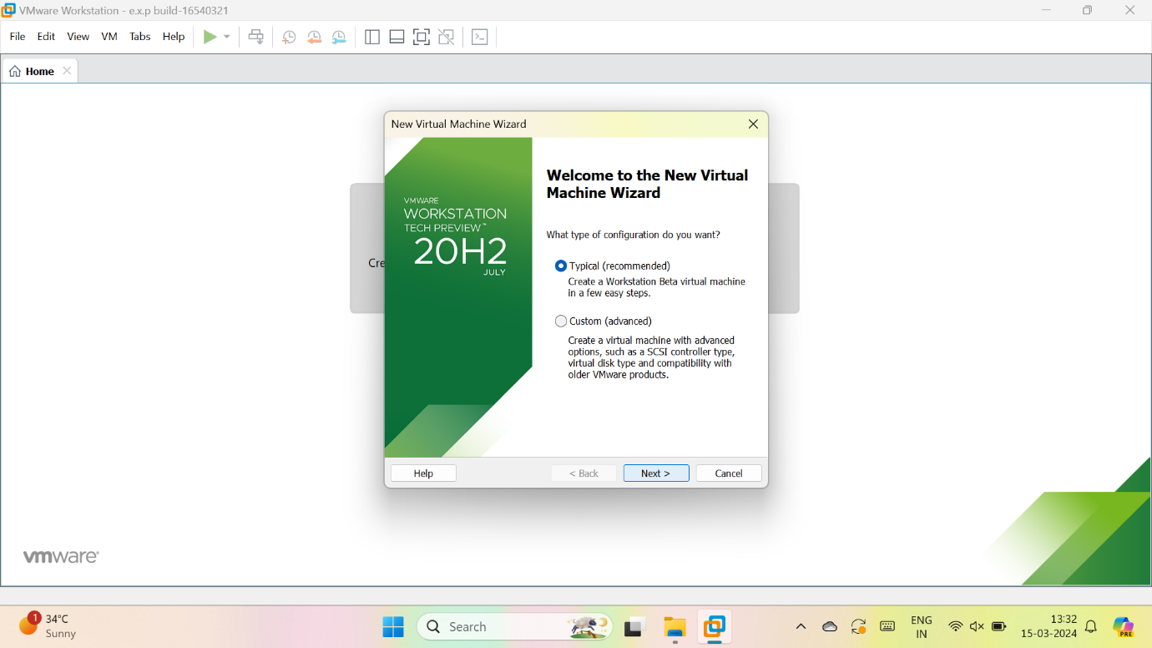

2.give name for VM

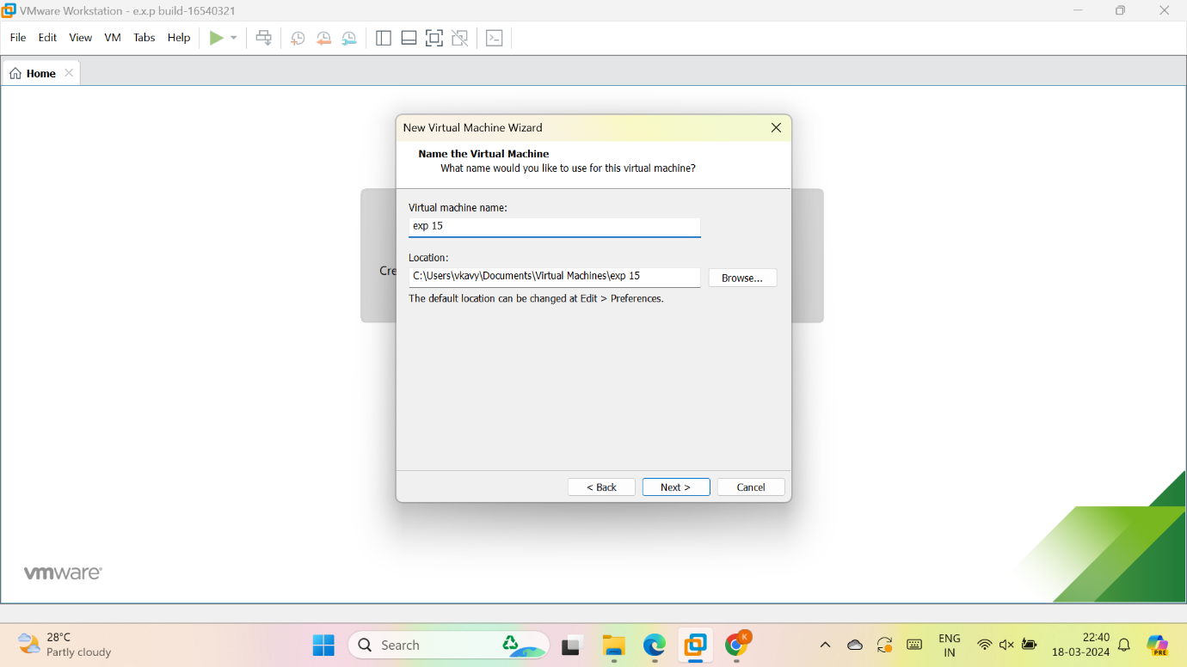

3.give the maximum size of disk and store virtual disk as a single file and give next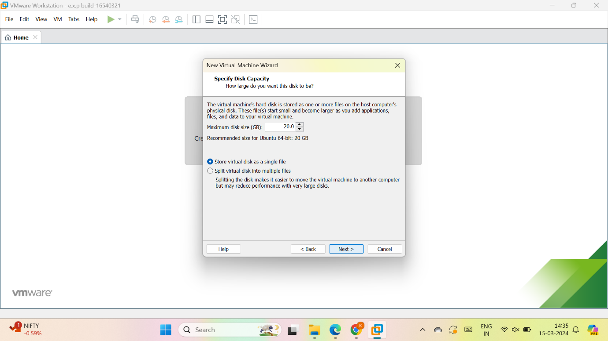

4.check the description

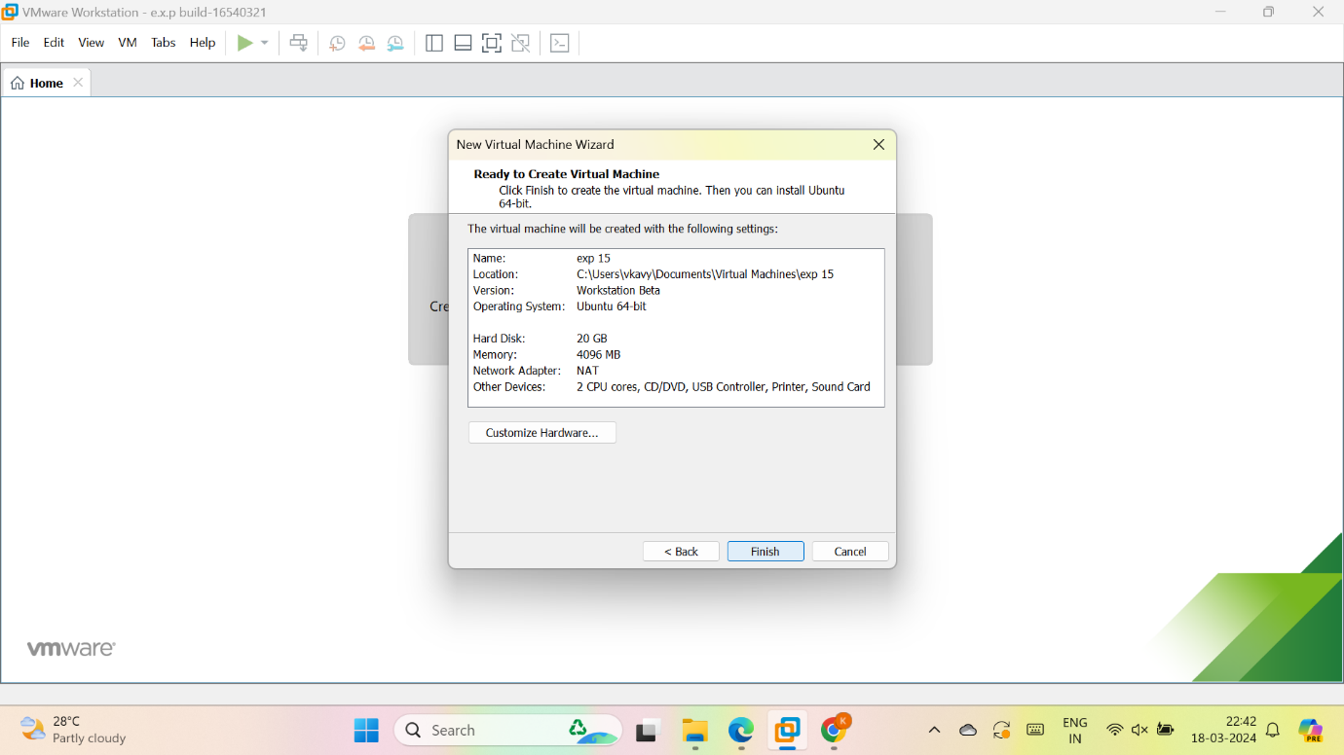

5.vm is created

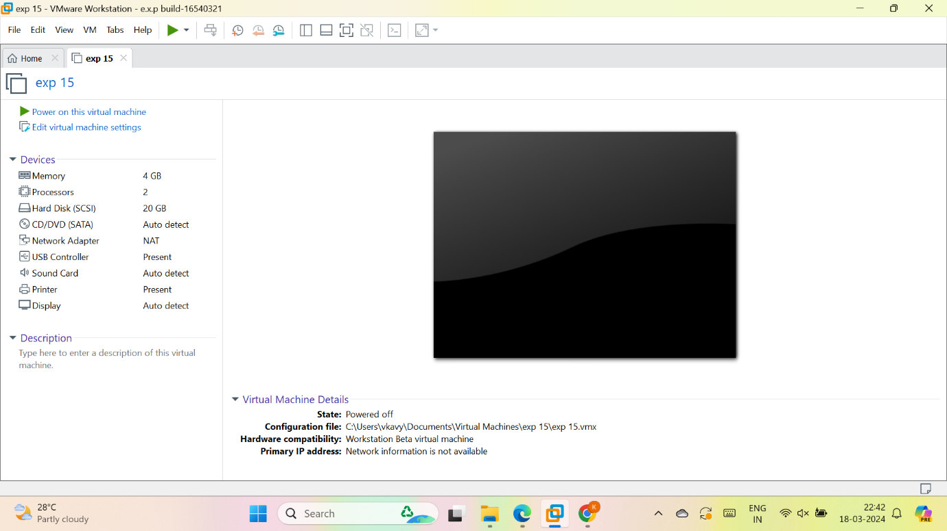

6. As per given question we have to Change Hardware compatibility

Select any hardware to change

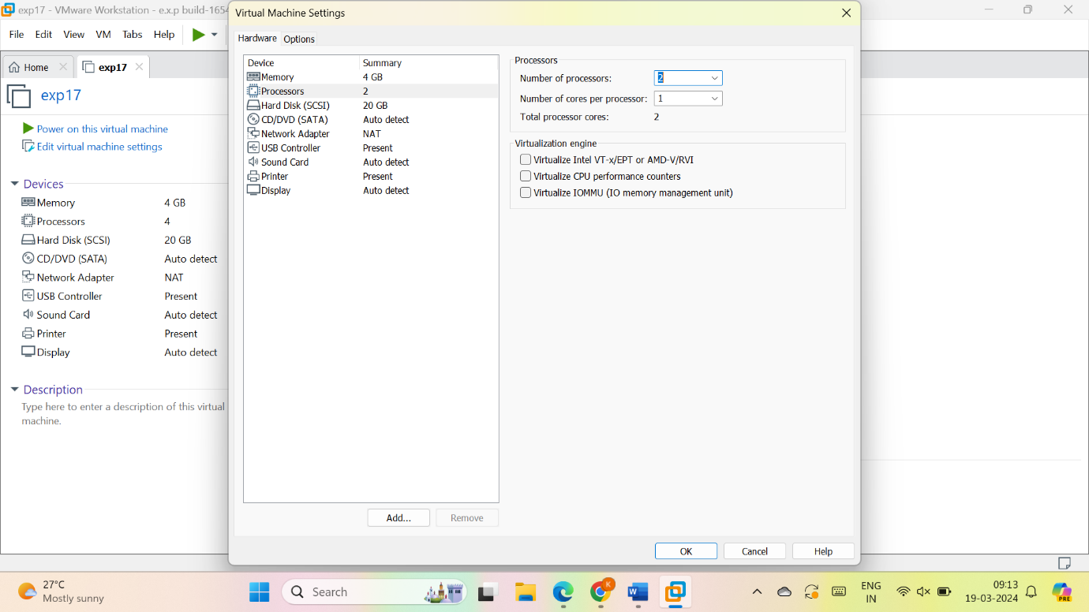

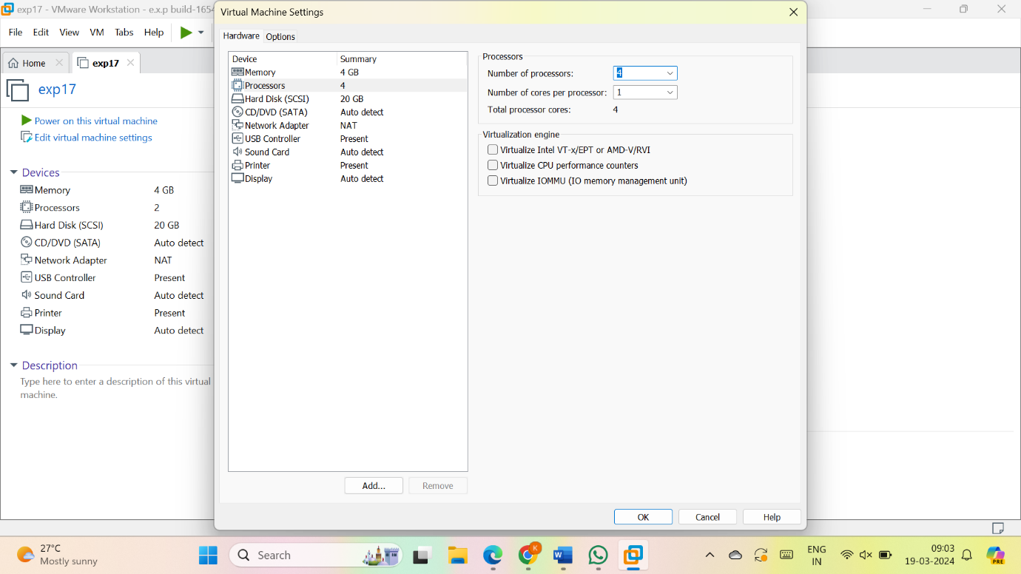

**RESULT:**

For the report processor has been changed

